1. **You do not have to write playbooks all the time. You can also run an ansible commands from CLI. It is called as ansible adhoc commands.**
2. **I.Q. Difference between ansible adhoc command and ansible playbook?**

* **Ansible adhoc commands used to execute 1 or 2 commands.**
* **Ansible playbook useful when there are multiple tasks or set of commands need to be executed on target machine**

**Examples are as below,**

**# ansible -i inventory all -m "shell" -a "touch devopsclass"**

**# ansible -i inventory all -m "shell" -a "df -h"**

**# ansible -i inventory all -m "shell" -a "nproc"**

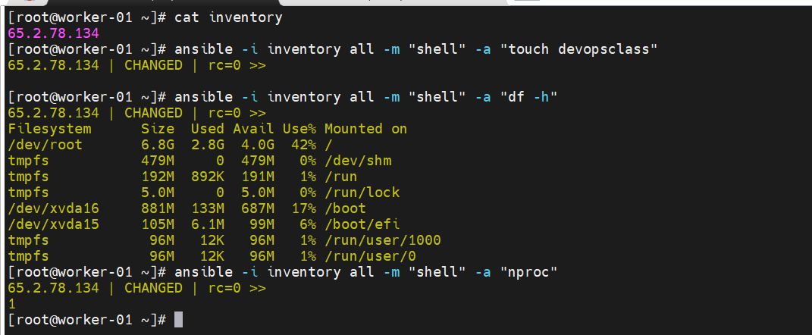

1. **Please refer ansible module documentation to perform tasks as nobody can remember all modules.**
2. **I.Q. How do you group the servers in ansible or how you can perform the tasks on certain machines?**

**You can do grouping of your servers in inventory file.**

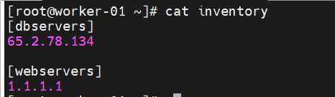

1. **Task: write a playbook to install and start nginx on target machine.**

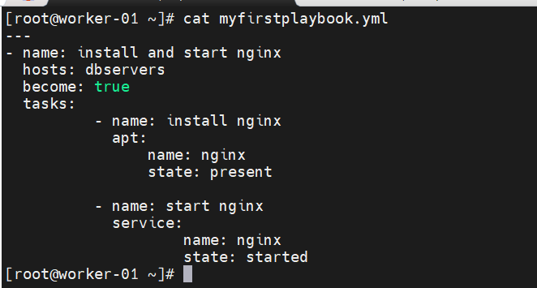

**# ansible-playbook -i inventory myfirstplaybook.yml**

**To run playbook use above command. We need to pass inventory argument in command since inventory file is not in default ansible path i.e. /etc/ansible**

1. **I.Q. What is ansible roles?**

**Ansible role is efficient way of writing a complex playbook.**

**e.g. Let’s say I want to configure Kubernetes by using ansible. So, it will have some close to 50-60 tasks. You have lot of variables, parameters, certificates, secrets while creating a Kubernetes cluster. So by using role you can segregate each and everything and properly structured the playbook.**

**# ansible-galaxy role init Kubernetes**

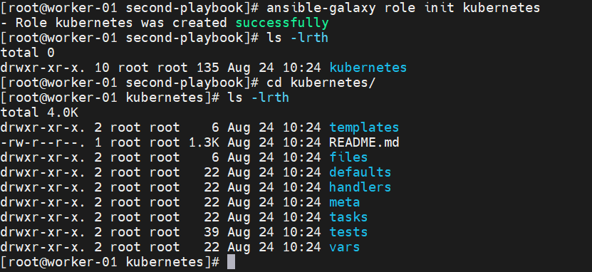

**Refer below github repo to understand the ansible playbook examples.**

[**https://github.com/ansible/ansible-examples**](https://github.com/ansible/ansible-examples)

1. **Interview questions FAQ.**

[**https://www.youtube.com/watch?v=j5PgN0J3d7M&t=4s**](https://www.youtube.com/watch?v=j5PgN0J3d7M&t=4s)